**Looking for Work**

**Work B.C.**

* Work B.C. helps people find jobs, explore career options and improve their skills.
* Revelstoke office

117 Campbell Ave

(250) 814-0244

[www.workbc-revelstoke.com](http://www.workbc-revelstoke.com)

**Social Insurance Number (S.I.N.):**

* You will need a social insurance number to work in Canada and have access to government grants and programs.
* There is no fee to obtain a S.I.N.
* You can apply in person:

Salmon Arm Service Canada Centre

191 Shuswap Street Northwest, Floor 1

* Or by mail: Social Insurance Registration

P.O. Box 7000

Bathurst, NB E2A 4T1

**Employment Insurance:** temporary financial assistance to those that are unemployed or have lost their jobs.

More information can be found at: <http://www.servicecanada.gc.ca/eng/sc/ei/index.shtml>

**Banking**

**Budgeting:**

* Budget worksheet <http://www.cba.ca/contents/files/misc/cba_budgetworksheet_en.pdf>
* Budget calculator
* <http://www.mymoneycoach.ca/budgeting/budgeting-calculators-tools/budgeting-spreadsheet>

**Retirement Savings:**

* Contributions are tax deductible
* Savings grow tax free
* You can convert your RRSP to get regular payments when you retire.
* You can borrow from your RRSP to buy your first home.
* For more info on RRSP’s: [http://www.getsmarteraboutmoney.ca/en/managing-your-money/investing/rrsps-for-retirement/Pages/Five-reasons-to-open-an-RRSP.aspx#](http://www.getsmarteraboutmoney.ca/en/managing-your-money/investing/rrsps-for-retirement/Pages/Five-reasons-to-open-an-RRSP.aspx)

**Pay Day Loans:** a very expensive way to borrow money.

* High interest rate and service charges can apply.
* These charges can get higher if you do not pay the loan back on time.

**Cheque Cashing Outlets:**

* They charge a percentage of your cheque plus a service fee to cash your cheque!
* You don’t need a bank account to cash a government cheque? You can bring it into any bank and they will cash it for free.



Photo credit Pepe Pont via Visualhunt.com CC BY-ND





Photo via Visualhunt.com



Photo credit kevin dooley via VisualHunt.com CC BY





**Your First Place**

When moving out on your own there will be some initial costs.

**Start up Expense worksheet:** <http://www.fcac-acfc.gc.ca/Eng/forConsumers/lifeEvents/movingOut/Pages/StartUpE-Grillede.aspx>

# On-Going Expense Worksheet:

# <http://www.fcac-acfc.gc.ca/Eng/forConsumers/lifeEvents/movingOut/Pages/StartUpE-Grillede.aspx>

**Finding a Home:** there area few other things to think about while you are looking for a place to rent

A list that will help you decide whether the different places you look at really meet your priorities: <http://www.fcac-acfc.gc.ca/Eng/forConsumers/lifeEvents/movingOut/Pages/StartUpE-Grillede.aspx>

**Moving In**: Before moving in, walk through the rental unit and make sure you note the condition of the property.

Fill out an inspection report with the landlord.

**Tips on Security/Damage deposits:** <http://www2.gov.bc.ca/gov/topic.page?id=E5B468D8506740A48F8ECFB6C75B0B64&title=Deposits%20and%20Fees>

**Your rights as a tenant:** [www.rto.gov.bc.ca](http://www.rto.gov.bc.ca)

**Detailed guide for tenants and landlords:** <http://www2.gov.bc.ca/gov/DownloadAsset?assetId=7534728F91F74AC7BFFB82EC9D68222B&filename=act_english.pdf>

Photo via Visualhunt.com



Photo credit teadrinker via Visualhunt.com CC BY-ND



**Life Events**

**Owning A Vehicle:** consider all costs associated with owning a vehicle.

* Canadian Automobile Association has a brochure on the cost of driving: <http://www.caa.ca/wp-content/uploads/2012/06/CAA_Driving_Cost_English_2013_web.pdf>
* Consider options to buy or lease
* Kootenay Car Share-gives access to a vehicle without owning one <http://www.carsharecoop.ca/car-locations/revelstoke/>

**Fraud Protection:** Fraud can be committed by anyone even immediate and extended family.

For more information on fraud and fraud protection visit <http://www.fcac-acfc.gc.ca/Eng/forConsumers/topics/fraud/Pages/home-accueil.aspx>

**Paying for Post-Secondary:** Take full advantage grants, bursaries and scholarships.

<http://revelstokesecondary.sd19.bc.ca/students-parents/grad-homepage/scholarships/>

<http://www.fcac-acfc.gc.ca/Eng/forConsumers/lifeEvents/payingPostSecEd/Pages/Grantsbu-Subventi.aspx>

<http://www.scholarshipscanada.com/>

<http://www.youth.gc.ca/eng/home.shtml>

[www.canlearn.ca](http://www.canlearn.ca)

[www.yconic.com](https://yconic.com/)

 For information on planning, funding options and loan applications visit: [www.studentaidbc.ca](http://www.studentaidbc.ca).

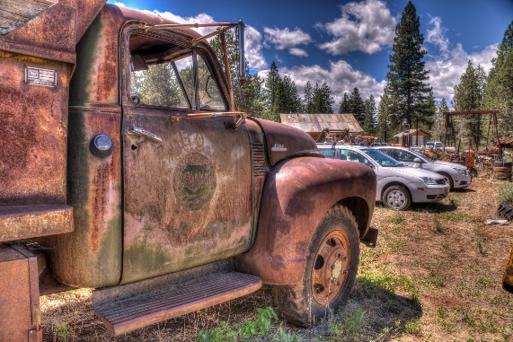

Photo credit Darron Birgenheier via VisualHunt.com CC BY-SA

Photo credit Joris_Louwes via Visualhunt CC BY

Photo credit abodftyh via Visual hunt CC BY-SA