**Getting Ready**

Update your budget to take into account new priorities

• <http://www.cba.ca/contents/files/misc/cba_budgetworksheet_en.pdf>

If buying used furniture or equipment, make sure the items are still safe for your child. Check Consumer Product Safety at: <http://www.hc-sc.gc.ca/cps-spc/pubs/cons/index-eng.php>.

## Birth Registration Services: Through Vital Statistics parents of newborn children have a quick and secure way to register for:

## [Canada Child Benefits (CCB)](http://www.vs.gov.bc.ca/births/birth_registration_services.html#ccb) [www.cra.gc.ca/benefits](http://www.cra.gc.ca/benefits).

* [Social Insurance Number (SIN)](http://www.vs.gov.bc.ca/births/birth_registration_services.html#sin)
* [Medical Services Plan for BC Residents (MSP)](http://www.vs.gov.bc.ca/births/birth_registration_services.html#msp)

<https://www.health.gov.bc.ca/exforms/msp/baby_enrolment.html>

Application for these services through Vital Statistics is only available when registering the birth of your child who is under the age of one.

Each program has its own eligibility requirements.

## Employment Insurance (EI) Maternity and Parental Benefit:

Can apply online at <http://www.servicecanada.gc.ca/eng/ei/application/employmentinsurance.shtml>

Information on EI benefits if you are self employed-<http://www.servicecanada.gc.ca/eng/ei/information/self_employed.shtml>

**Insurance:** Check the type of insurance coverage and the amount through your employer. If you don’t think that you have enough coverage, you can buy private coverage through an insurance broker.

**Employment Insurance-Compassionate Care Benefit:**

* Must apply online for this benefit.
* Can receive benefits for caring for a variety of family members including that of your spouse or common-law partner.
* Can receive benefits for a maximum of 26 weeks.

Contact Service Canada for information on these benefits:

1-800-227-9914 for CPP/OAS benefits, 1-800-206-7218 for Employment Insurance.

www.servicecanada.gc.ca

**Savings and Investment**

**Federal Education Grants:**

**Canada Learning Bond:** Government grant for low –income families to help them start saving for their child’s postsecondary education. <http://www.cra-arc.gc.ca/tx/ndvdls/tpcs/resp-reee/cesp-pcee/clb-eng.html>.

**Canada Education Savings Grant:** is money the government adds to your child's Registered Education Savings Plan (RESP).

If your child does not attend school after high school the grant money received must be paid back to the Government. The money you invested stays with you.

You do not need to be the primary caregiver to open an RESP for a child.

**Provincial Education Savings Grants:**

**B.C. Training and Education Saving Grant:** A $1200 grant from the provincial government. Can apply when child between the ages 6-9.

For information [bctesp@gov.bc.ca](mailto:bctesp@gov.bc.ca)

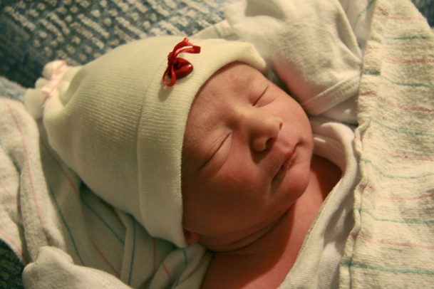

Photo credit CodyR via VisualHunt CC BY



Photo via VisualHunt.com



FreeImages.com-Pat

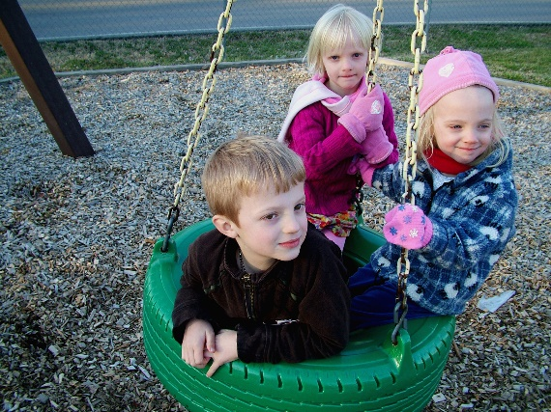

FreeImages.com-Ned Horton

**After Your Child Arrives**

**Benefits:**

**Medical Service Plan- Premium Assistance and Pharmacare/Fair Pharmacare:** Helps B.C. residents with the cost of medical premiums, prescription drugs, medical supplies, and pharmacy supplies based on their income level.

For information on these two programs contact Health Insurance B.C. 1-800-663-7100.

**B.C. Employment and Assistance Program:** Aids B.C. residents by providing income assistance to those who are unable to fully participate in the workforce.

Provides money for shelter and food costs, and additional assistance and benefits.

For information on these two programs contact the Ministry of Social Development and Innovation 1-800-866-0800.

**Canada Child Benefit:** If you are not currently receiving any child benefits you can apply through the online service “Apply for Child Benefits” on [My Account](http://www.cra-arc.gc.ca/esrvc-srvce/tx/ndvdls/myccnt/menu-eng.html).

Or you can use [Form RC66, *Canada Child Benefits Application*](http://www.cra-arc.gc.ca/E/pbg/tf/rc66/README.html).

Information on the Canada Child Benefit visit: <http://www.cra-arc.gc.ca/gncy/bdgt/2016/qa01-eng.html>.

If you used the Birth Registration Services do not re-apply!

### [**Child Disability Benefit**](http://www.servicecanada.gc.ca/eng/goc/cdb.shtml) **(CDB):** tax free benefit for families with a child who is severely mentally or physically impared.

<http://www.cra-arc.gc.ca/E/pbg/tf/t2201/README.html>

### **B.C. Early Childhood Tax Benefit (BCECTB:** is a non-taxable monthly benefit to help eligible families with the cost of raising children under six years of age.

### **B.C. Family Bonus (BCFB)** a non-taxable amounts paid monthly to help *low- and modest-income families* with the cost of raising children.

**Child Care Resource and Referral**: can help with information on child care options, and the Child Care Subsidy.

Visit [www.childcarechoices.ca](http://www.childcarechoices.ca) , or [www.revelstokechildcaresociety.com](http://www.revelstokechildcaresociety.com)

**Directories and Initiatives:**

## Revelstoke Children’s Services Directory

<http://www.revelstokeearlychilddevelopment.com/young-childrens-directory.html>

## Revelstoke Prenatal Service Directory

<http://www.revelstokeearlychilddevelopment.com/prenatal--postpartum-info.html>

## Early Childhood Development Committee (ECD)

<http://www.revelstokeearlychilddevelopment.com/>

Photo via VisualHunt.com



Photo credit Ryan Leighty via Visual hunt CC BY



Photo via Visualhunt.com

Photo via VisualHunt.com